Room B Q1chol ecystectomy Complications
Stem: You are called to the ER to see a 65-year-old man who presents with worsening epigastric and RUQ abdominal pian, 3 days after laparoscopic cholecystectomy for acute, calculous cholecystitis.
Reports, PO intolerance, chills, fevers, jaundice, darkened urine.
He is otherwise without significant past medical or surgical history.
Vitals : HR 114bpm, BP 94/37; 94% on RA, 38.8C
PE: Ill appearing, lethargic, jaundice, scleral icterus Mildly distended, TTP in the RUQ and epigastrium.
labs: WBC 16.4k; Tbili 4.3; AST 143; ALT157; ALK Phos 312; Creatinine 1.73 (normal 0.90)

Stem: You are called to the ED to see a 78 yo man who presents with 3 day history of fevers and chills, sweats and feeling poorly. He reports RUQ abdominal pain and some nausea but no emesis. He is otherwise healthy.
Vitals: T=99.9 degrees, BP=100/60, HR 110, and RR of 20.
Physical exam : Tender to palpation in the right upper quadrant without guarding or peritoneal signs.
Labs: WBC of 18K, LFTs slightly elevated, otherwise rest of labs normal.
PMH/PSH: Diverticulitis. Colonoscopy 1 year ago with diverticulosis

Scenario 2: Same patient arrives, RUQ US notes intra and extra hepatic ductal dilation, mild fluid, no stone is appreciated. You are now in a tertiary center with all images and expertise available. You gets ERCP and there is a Concern for clip across CBD.Patient is on Antibiotics
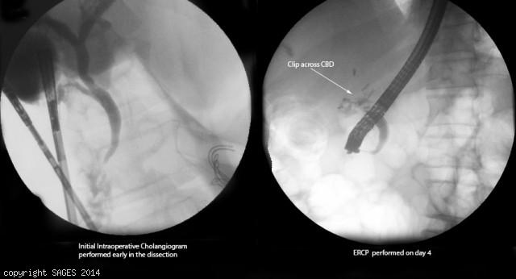
- Antibiotics
- IR consultation for PTC.
You take the patient to the OR for repair, how do you repair the following?
- Injury < 50% circumference, not caused by caut ery -Repair over T tube.
- Transection < 1 cm in size and away from bifurcation-End to end anastomosis.
- More severe injury, or close to the bifurcation:Hepaticojejunostomy -- Describe.
  - Identify CBD
  - Place two traction sutures on either side of the dilated bile duct.
  - The distal CBD is ligated.
  - The duct is divided below the traction sutures.
  - The end of the common duct is then trimmed to achieve maximal diameter.
  - fashion a Roux-en-Y jejunal limb
  - This limb is identified and transected with a stapling device 30-35 cm from the ligament of Treitz.
  - A single-layer anastomosis can be performed by a side-to-side anastomosis to the Roux limb

